AP Calculus

Volumes of Rotation Problem

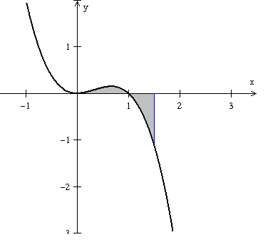

The shaded area shown at right is the area enclosed by the graph of .

a) Calculate the area shown.



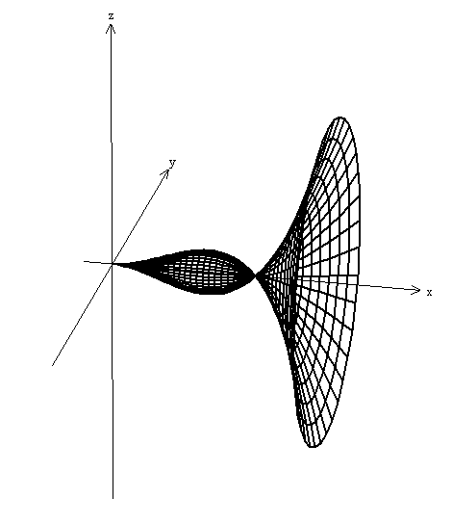

b) If the area shown above is rotated around the x-axis, what is the

volume of the solid that results from this rotation?

